Interpreting a timetable

TIMETABLE TASK
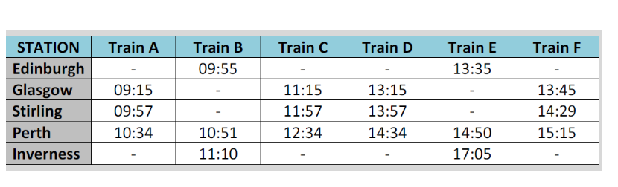

1). Which stations does Train E not stop at?

2). How long does Train B take to travel from Edinburgh to Inverness?

3). Ellen is at Glasgow station at 1:30pm. She wants to travel to Perth. She catches the next train. At what time will she arrive in Perth?

4). Billy gets to Stirling at 11.58 wanting to go to Perth. How long does he have to wait for the next train to Perth?

5). Sue wants to go to Perth but misses the 09.55 train at Edinburgh. She decides to get a taxi to Glasgow to catch the 11.15 train to Perth. She leaves at 10.03. How long does she have to get to Glasgow, with 5 minutes to spare?

6). Ralph is visiting from Germany. He asks Tammy for the quickest train of the day from Stirling to Perth. Tammy tells him to go for Train F. Is she correct?

