- Batman, Wonder Woman and Superman have lined up to meet the press. The photographers want to get as many different photographs as possible. How many different ways can the three heroes line up so there are different photographs?
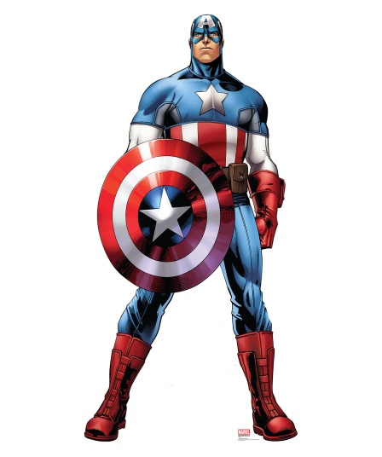
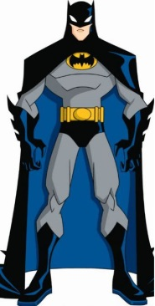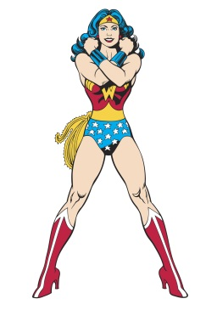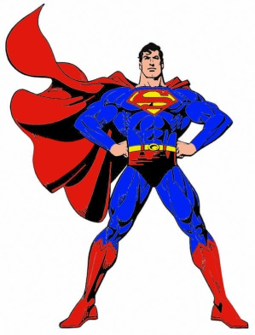
Write all the different possibilities in your book. Use a code to save time! e.g. B= Batman, W=Wonder Woman, S =Superman
How many different ways can they line up?
2) Holy Confusion! Now Captain America has arrived to join the group!
Write out all the possibilities with 4 heroes in the photographs. Use C for Captain America.
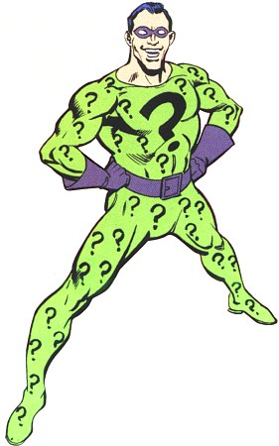
CHALLENGE!
Holy villainy! The Riddler has arrived! A villain can only have his photograph taken when guarded by 2 heroes. Write down all the different combinations that are possible now – remember, The Riddler must be in every photograph but only two of the four heroes can be in it. There are a lot of possibilities! Use R for the Riddler.

