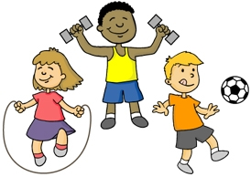
Keeping your mind and body active and healthy
Here is a list of ideas which may help your body and mind stay healthy during this time:
- Dance along to Fortnite Dances on Fortnite Fitness Youtube channel.
- Relax with Cosmic Kids Yoga on Youtube.
- Get Fit with Joe Wicks by following the Body Coach 5 Minute Workout video on Youtube.
- Dance and sing along to dances on GoNoodle on YouTube.
- Learn some of the dances on JustDance YouTube videos.
- Exercise Indoors (star jumps, jogging on the spot, stretching).
- www.bbc.co.uk/teach/supermovers
- Smiling mind- short audio sessions to help with mindfulness.
- Mindfulness colouring with some calm music in the background.
- https://www.youtube.com/user/ArtforKidsHub - learn to draw something of your choice with this guided video. Listen and follow instructions to draw a picture of something you can carefully colour.

