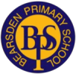
Bearsden Primary School
Home Learning Reading Guide for Families

Blooms Taxonomy to Support Comprehension and Analysis of Reading
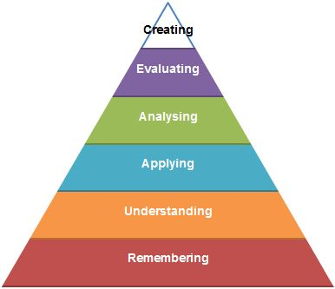

This guide contains:
- An overview of Bloom’s Taxonomy and how it can support family learning in Reading;
- Examples of Blooms questions for learners working at Early and into First Level (Primary 1 to Primary 4); and
- Examples of Blooms questions for learners working at Second Level (Primary 5 to Primary 7).
Bloom’s Taxonomy provides learning levels to increase higher order thinking skills for children of all ages. The levels begin with Remembering and progress to Creating. Bloom’s Taxonomy provides families with a structure to support reading at home; it ensures that children are answering and asking a range of questions that demand different levels of thinking. It is important for children to progress through the levels in order to develop a deep understanding of text and to be able to apply reading skills across other aspects of learning.

Each level of Bloom’s taxonomy is explained as follows:
Remembering
The Remembering level of Bloom’s Taxonomy includes questions that involve who, what, where, when, why and which. This level of questioning demands the lowest level of thinking in children; they are simply recalling basic facts about a text.
Understanding
The Understanding level is slightly more complex than simply recalling information; it requires learners to demonstrate a level of comprehension or understanding of the text. At this level, children are asked to explain, infer, classify or summarise.

Applying

At the Applying level, learners are asked to use what they have learned in a new way. At this level, children may be asked to solve a problem, construct their own ideas or experiment.

Analysing

At the Analysing level, learners have to find evidence in the text to support or justify their opinions. This requires children to be able to break the text down through categorising and ordering ideas.

Evaluating

By the time learners reach the Evaluating level, this places high demands on children in terms of critical thinking skills. Children are asked to make decisions about the text based on a set of criteria, to prove or disprove, to justify or to give an opinion.

Creating

The highest order thinking skill is the Creating level. Here, children are challenged to organize information in a new or unique way. They are asked to design or construct their own questions about the text, to invent new possibilities and solutions about the text, to debate and create reflective summaries.

Bloom’s Taxonomy Early/First Level (Primary 1 to Primary 4)

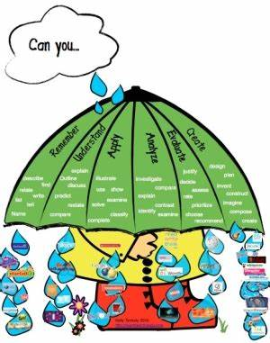

Ask your child questions like these to help them to develop their comprehension and analysis skills at each of the Bloom’s Taxonomy levels:

Remembering
What happened at the beginning of the story? How did the story end?
Who is the main character? Tell me something about them.
Where and when does the story take place?
Doe the whole story take place here?
What has happened so far?
What happened before/after?
Who or what were…?

Understanding
Discuss the front cover of your book. What does it tell you about the story?
Who is your favourite character? Why do you like them?
What do you think might happen next? How do you think the story might end? Can you explain what changes are happening to the character/events?
What is the main idea of this section?

Applying
What sort of character is….?
If you were the main character, what would you do differently?
Does this remind you of something that has happened to you? Tell me about it.
What would you do if.. happened to you?
What would you ask your favourite character?
Analysing
Which part was the most exciting/saddest/funniest? Why?
Did the character feel the same at the beginning, middle and end of the story? Do they change at all?
What does the author want readers to learn from the story?
Is this book better than another you have read? Why?

Evaluating
Do you think the main characters were good or bad? Find words in the text to show why.
What did you like about the story? Can you explain why?
Rate the story out of 5. Why have you given it that score?

Creating
Can you think of another way you could solve the problems in the story?
Could the ending be different? What would it be?
If you could give the story a new name what would it be?
If you were a character in the story what would you do?
How do you think the author could have improved the story?

Bloom’s Taxonomy Second Level (Primary 5 to Primary 7)

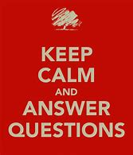

Remembering
Tell me about the main characters. What have we found out about them that we did not know before?
Where and when does the story (or event) take place?
What are the main events of this chapter/section?
What facts have we learnt in this chapter/section?
Can you find the word for...?

Are there words that you don’t understand? Look up the word definition.

Understanding
How would you describe a character? What type of person are they?
Explain what changes are happening to the character/events?
What is the main idea that the reader might have taken from this paragraph/chapter?
Summarise the main events and explain how they relate to the main idea of the story.
Find phrases in the story that you are not sure of and use you inference skills to work out a possible meaning.

Applying
Has anything similar happened to you? Tell me about it.
How could you solve the problem that the characters face? What alternative solutions are there?
What would you ask a character if you could speak to them?
Could the events have happened in real life? How do you know this?

Analysing
Why do you think...?
What evidence can you find to show...?
If... happened, what might have happened next/in the end?
What is the relationship between...?
What was the turning point of the story?

Evaluating
How would you have handled..?
What is your opinion of...?
How would you feel if...?
Give reasons for and against...?

Creating
Can you suggest a better way or an alternative to...?
How could you change the plot of the story?
What changes would you make to...?
Suppose you could... what would you do?
Create questions of your own about the text – Literal, Inferential and Evaluative.

Bearsden Primary School
March 2020

